# Report Check Stock Shipping Locator di Inventory Move Warehouse

1. Di document Inventory Move Warehouse (Approve) klik lambang proses dan klik Stock Check (IMW)

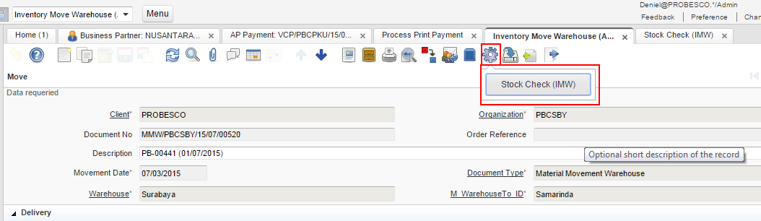

1. Hasil Print Out

