# Report Check Stock Shipping Locator di Inventory Move Warehouse

1. Di document Shipment (Customer) klik lambang proses dan klik Stock Check (DO)

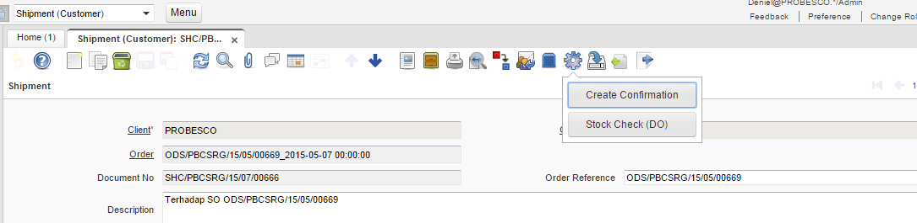

1. Hasil Print Out

