**Step by step Export e-Faktur dari Program ERP (Idempiere)**

1. Pastikan komputer Anda sudah terinstall aplikasi OpenOffice
2. Jika belum, bisa di download, klik disini <http://probesco.com/downloads/>

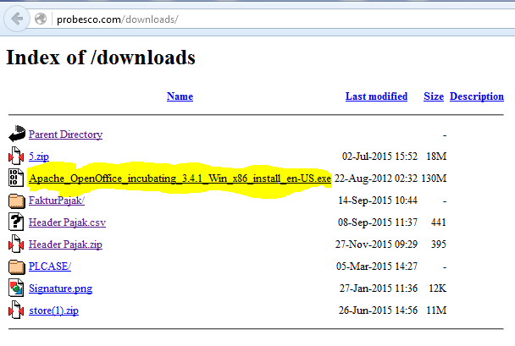

1. Setelah download selesai >> buka folder download >> Double Click icon **OpenOffice.exe**

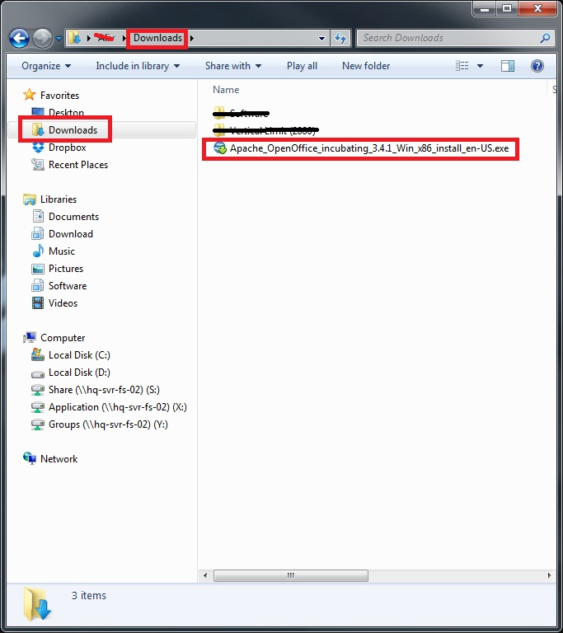

1. Setelah itu muncul Pilihan Extract >> Pilih Extract >> Next >> Next >> Next >> Install
2. Lalu buka Program ERP >> Log In >> Gunakan Role AR Admin >> Buka window **Report View E Faktur**

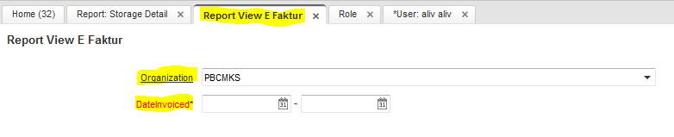

1. Pilih Organization sesuai SBU >> Pilih tanggal mulai dan tanggal akhir penarikan report >> Start
2. Pilih Menu Export (1) >> Pilih File of Type : **csv – csv …** >> Ceklist

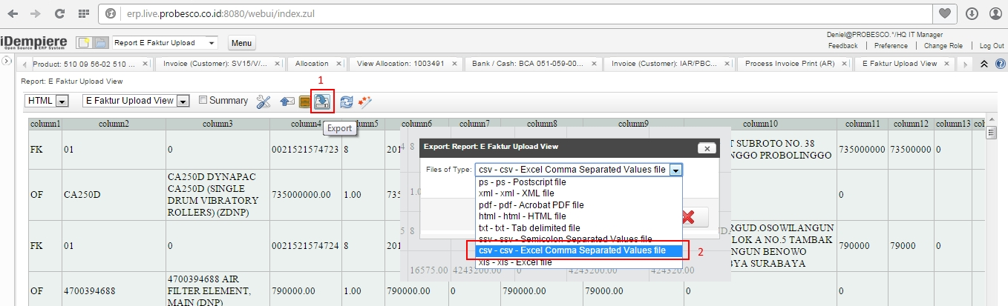

1. Setelah download selesai >> buka folder download >> Klik kanan di file Report View E Faktur.csv >> Open With >> OpenOffice.org Calc
2. Ceklis Comma [1] >> Pilih Text delimiter (*) tanda bintang [2] >> Klik di kotak [3] >> Pilih Text [4] >> OK

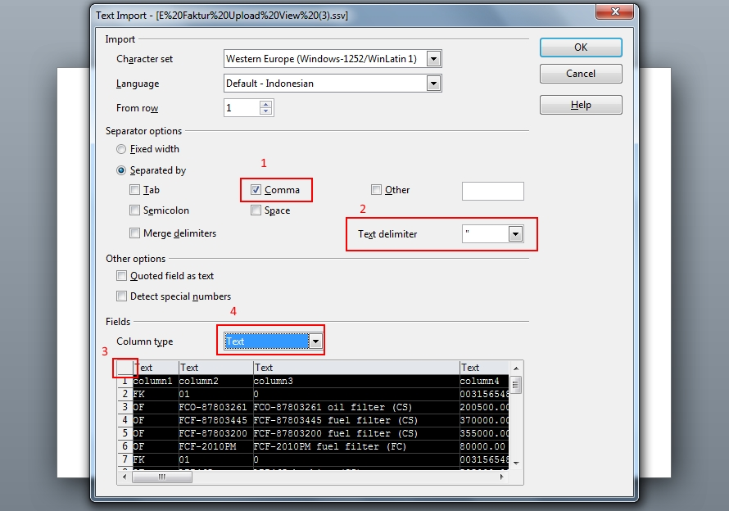

1. Edit Sheet ---- Hapus Column T(column 20) dan U(column 21) >> Pilih Kolom [1] >> Klik Kanan, Delete Columns [2]

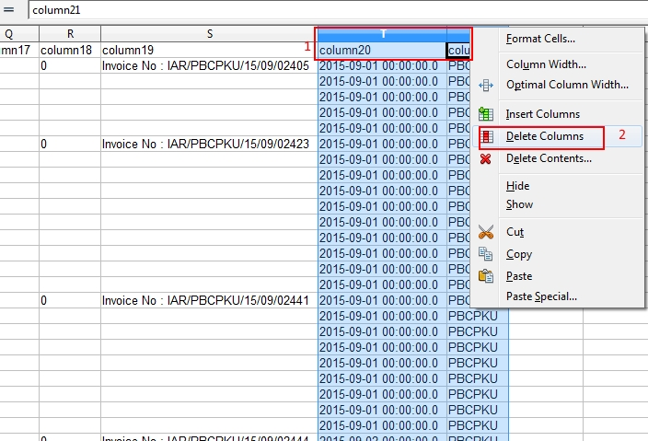

1. Edit Sheet --- Delete Row 1 >> Klik di Row 1 (Block Row 1) >> Klik Kanan >> Delete Row

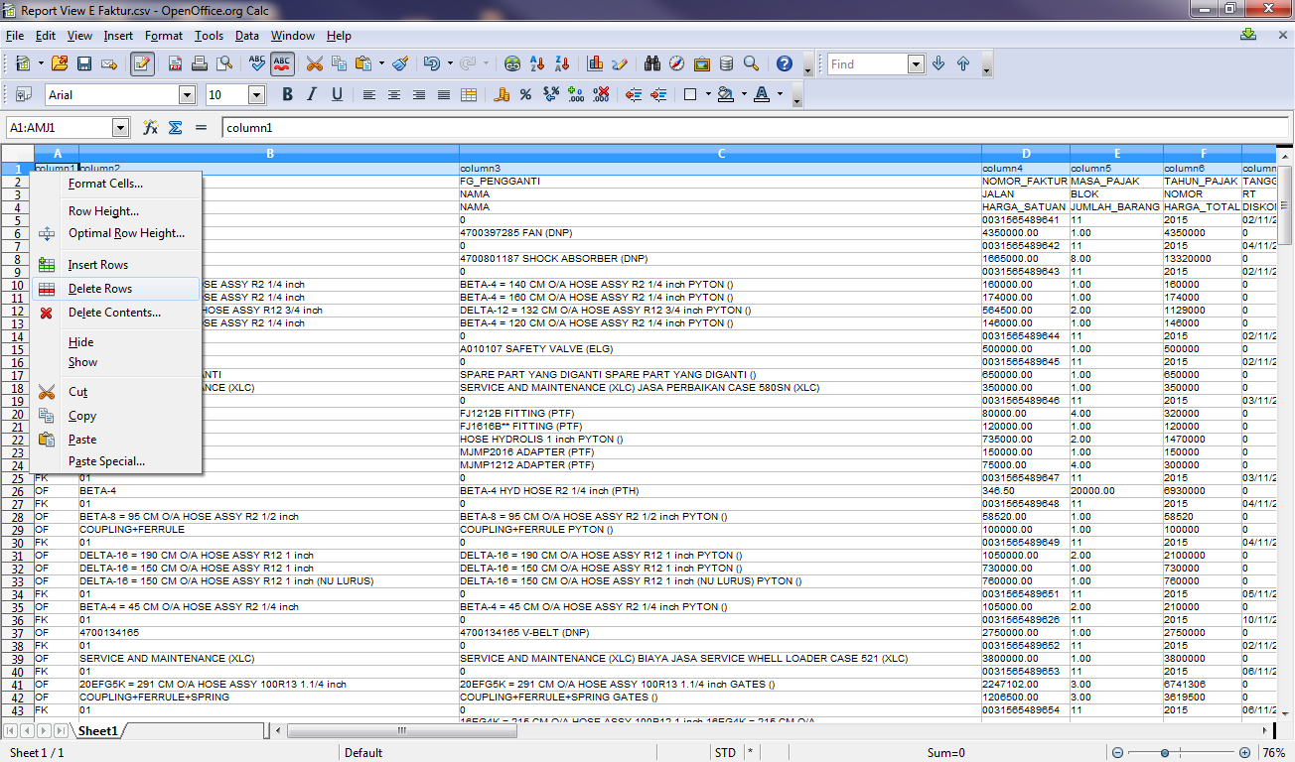

1. Edit Sheet ---- Insert Rows (3x) di Row Paling Atas >> Klik kanan di Row 1 >> Insert Rows (3x)

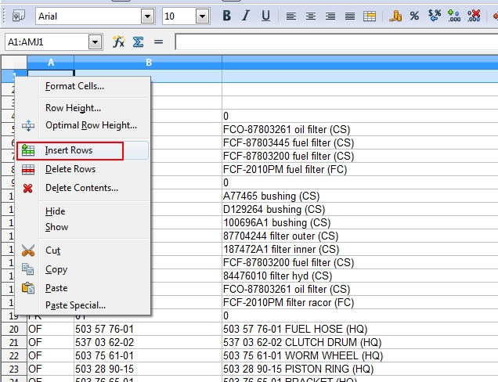

1. Buka File Header Pajak.csv --- Bila belom ada, download attachment dari postingan ini (bagian paling bawah)

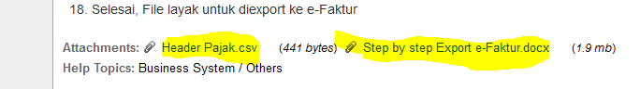

1. Setelah download selesai >> buka folder download >> Klik kanan di file >> Open With >> OpenOffice.org Calc
2. Ceklis Comma [1] >> Pilih Text delimiter (*) tanda bintang [2] >> Klik di kotak [3] >> Pilih Text [4] >> OK



1. **COPY** Row 1,2,3 dari File Header Pajak.csv **PASTE** ke Row 1,2,3 dari File Report E Faktur

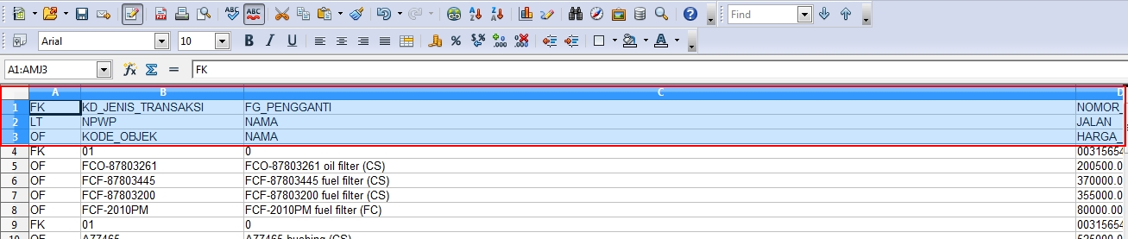

1. Save file yang telah diedit --- Pilih Menu File >> Save As [1] >> Ceklis Edit filter setting [2] >> **SAVE**

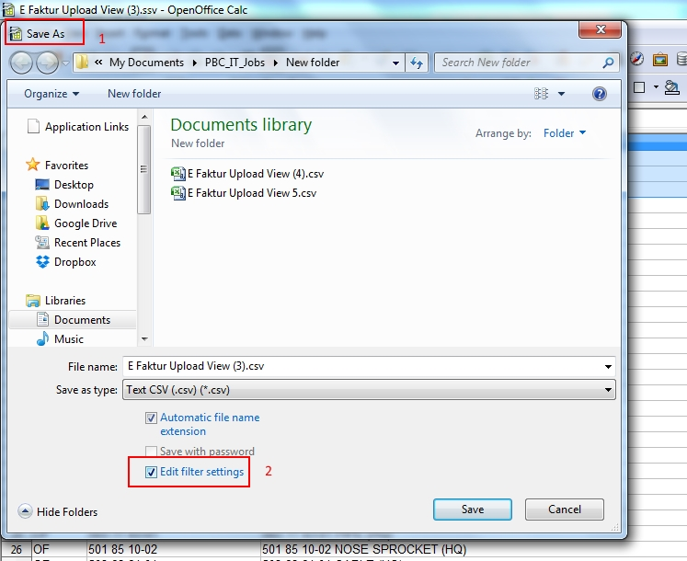

1. Export Text File --- isi Field delimeter dengan tanda (;) titik koma [1] >> Text delimeter di kosongkan[2] >> Ceklist Save cell content as shown [3] >> OK

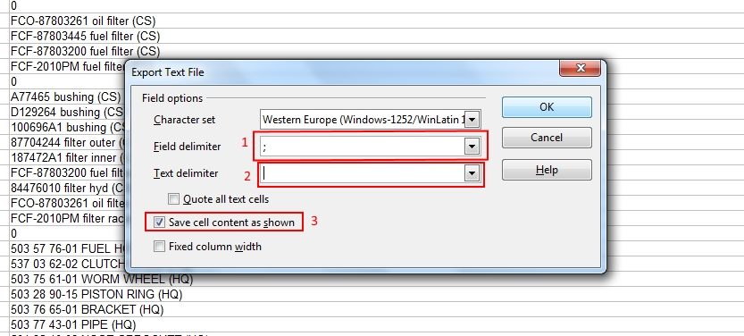

1. Selesai, File layak untuk diexport ke e-Faktur